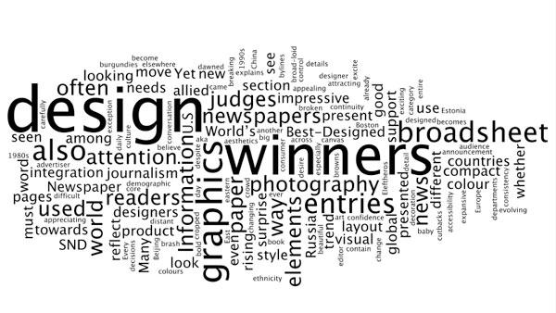Star re-design project
The following items must be included in your Star re-design project presentation proposal. You will turn in one copy to me at the time of your oral presentation and you will do one display board, so that the class can see a visual of your design as you explain it:
PART I (60 points)
- Five new ideas to improve circulation next year. How can we get the Star into more people’s hands. (5 points)
- Five new motivational ideas to encourage the staff to complete assignments in a timely and thorough manner. (5 points)
- A production ladder identifying what sections will be assigned to what pages. (Keep in mind that the number of pages must be divisible by eight and that we are currently producing a 40-page monthly) (5 points)
- Theme ideas for each month (Oct.-Dec. and Feb.-May) with four sample story ideas for each theme. Make sure you can show us where you're going with your ideas. (45 points)
PART II (35 points)
- Identify the standing elements of design for the paper.
  - Body Copy: Font, size (5 points)
  - Headlines: Font, size (5 points)
  - Decks: Font, size (5 points)
  - Bylines: Font, size (5 points)
  - Captions: Font, size (5 points)
  - Lines around photos (yes or no – and if yes, what size?): (1 point)
  - Drop caps: Size, font (3 points)
  - Pull quotes: Size, font, style (6 points)
* Please make sure that examples of all these items are included in your sample layouts.
PART III (165 points)
Design eight sample pages for next year's Star, a front page and one representative page from each of your five sections. Make sure that all standing elements that you want to include are on the page somewhere in the layout.
- Front page design
  - Flag: paper name, school name, address, phone, e-mail, web page address, volume & issue number, graphic (whatever applies) (10 points)
  - Teasers: graphic/photo/art, page number, copy (10 points)
  - Sample front cover layout & design (10 points)
- News page design
  - Briefs: produce a sample briefs box (5 points)
  - Other standing element(s) of your choice (5 points)
  - Sample news page layout and design (10 points)
- Sports page design
  - Briefs: produce a sample briefs box (5 points)
  - Other standing element(s) of your choice (5 points)
  - Sample sports page layout & design (10 points)
- Feature page design
  - Profile: produce a sample profile design (It’s My Life, but something different) (5 points)
  - Other standing element(s) of your choice (5 points).
  - Sample feature page layout & design (10 points)
- Entertainment page design
  - Produce a rating system for the reviews (5 points)
  - Other standing element(s) of your choice (5 points)
  - Sample entertainment page layout & design (10 points)
- Opinion page design
  - Design a sample column title and produce a graphic (5 points)
  - Other standing element(s) of your choice (5 points)
  - Sample opinion page layout and design (10 points)
- Design a staff page that includes: editor names and/or photos, professional affiliations (JEA/NSPA, NIPA), editorial policy, staff names and staff philosophy (20 points)
- Design a table of contents page that includes contents of the issue (20 points)
PART IV (125)
Design and place 5 advertisements per person. The ads must be placed at the bottom of your sample pages and can be any size as long as they are consistent.
- Select five businesses in our area that you wish to design a potential ad for.
- Ideally, you will take your proposal to the business when you attempt to sell them an ad for next year.
- Each advertisement must include:
  - A headline (not the name of the business) (5 points)
  - Body copy (5 points)
  - Graphic/Art/Photo (5 points)
  - Essential Information: Business name, address, phone, business hours, logo. (5 points)
  - Selling point for Century readers (5 points)
* Please note that each ad is worth 25 points, therefore five ads are worth 125 points. I want you to realize that this is a sizable chunk of this project. Ads are important to our publication!
PART V
Creativity and originality comprise a major portion of any newspaper's design. Make special considerations when considering the following:
- Readability
- Interactive, user-friendly ideas
- Audience specific
- Good combination of copy/art/photo/sidebars etc.
Use the Shopping List on page 203 of "The Newspaper Designer's Handbook" as a springboard. Do not let this list limit you.
Assessment:
- Students will be graded using an extensive rubric that assigns point values to the successful completion of each part (Total – 385 points)
- Students will also be judged by a panel of readers who will include:
  - teachers
  - students
  - professional designers
*It is very important to select some people who are not trained in the field of journalism, because you will get an accurate reflection of readability and what attracts them to your publication.
Materials & Resources:
- Tim Harrower's "The Newspaper Designer's Handbook" (Page 197-208)
- Computer lab with access to InDesign CS5
- Presentation board: Students will present a visual proposal to be displayed around the room for easy comparison.
- Separate 8 1/2 x 11 printout of product for grading
- Copies of current high school paper
- Copies of other high school papers from around the country
- Copies of professional newspapers from the area and of national publications (online)

